SCCF/02035/2021 LORNA ARWA

ASSIGNMENT: UI DESIGN FOR TO DO LIST PROJECT

Image

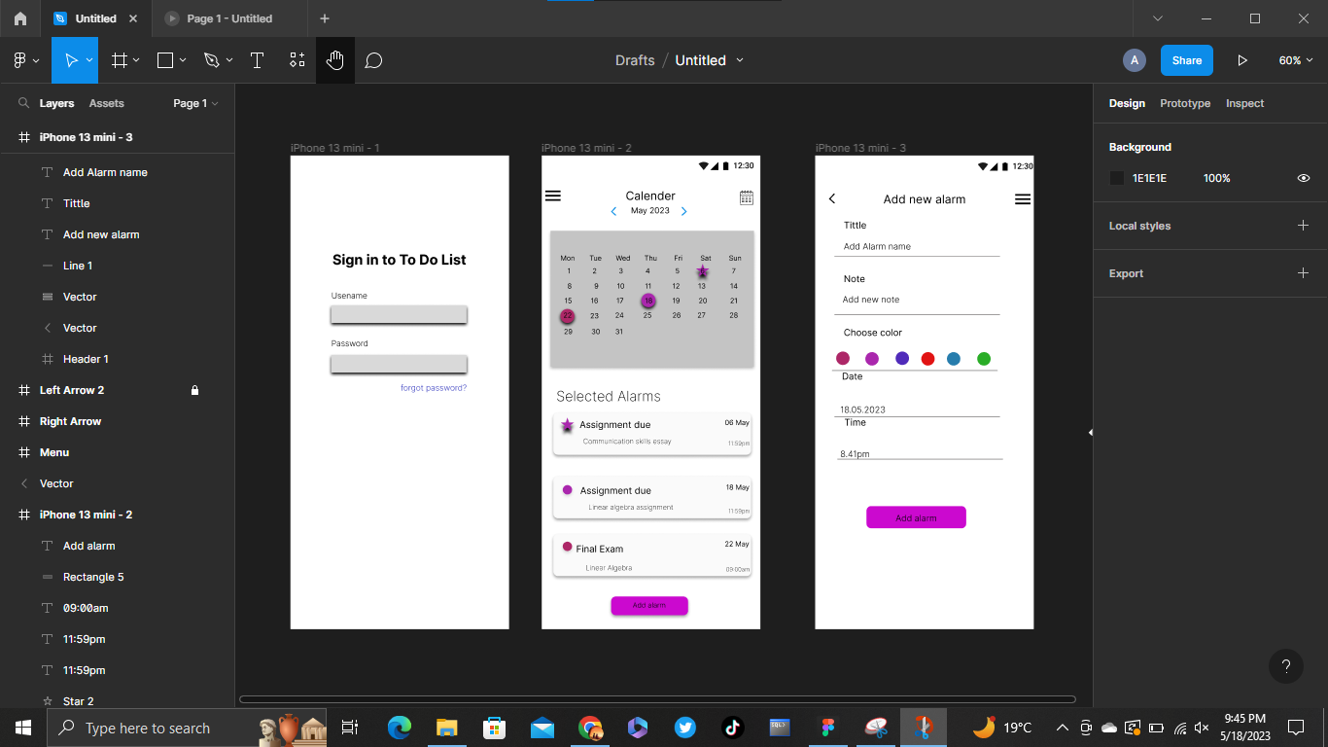

Image

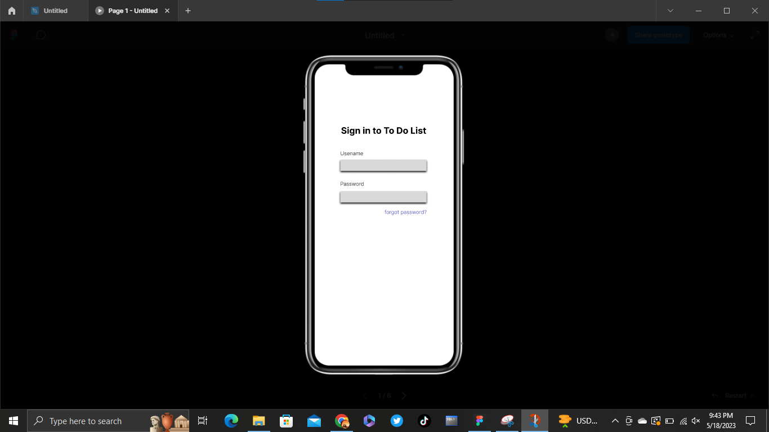

Image

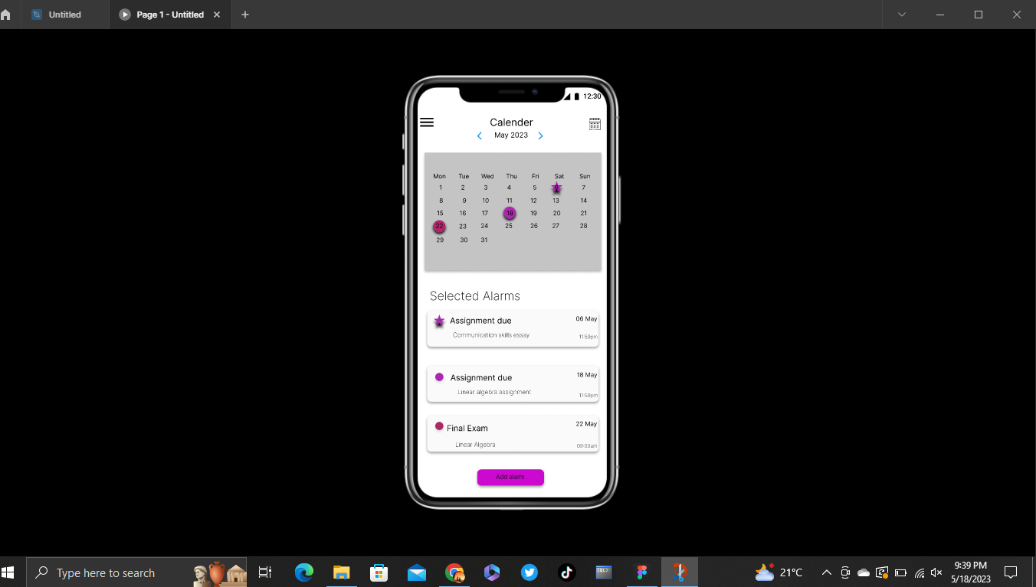

Image

